COMMUNICATION GUIDELINES SUMMARY
WWF GEF PROJECTS

2023

Contents
1. Introduction: 3
2. GEF Communication and Brand Guidelines: 3
a. GEF Brand: 3
b. GEF Visibility in Agencies’ Contractual Agreements: 4
c. The GEF Communication and Visibility Policy: 5
d. Communication and Visibility Guidelines for External Actions Funded by the GEF: 5
e. GEF Funded Projects: 5
f. GEF Funded Programs: 6
o Publications: 6
o Websites, Newsletters: 6
3. WWF-US Brand Guidelines: 7
a. Using the Panda symbol/logo: 7
b. WWF Panda logo use and placement: 7
c. Institutional Statements: 8
d. WWF Editorial Style: 9
e. WWF Photo Credit & Caption Style: 9
f. WWF-US Sustainability Policy: 9
4. Useful guidance attached in shared folder: 10

- Introduction:
This document presents the key aspects of the GEF and WWF branding and communication guidelines for GEF Implementing Agencies to help ensure overall coherence to the communications activities and efforts of the project. These guidelines are based on the GEF Council-approved policy on communications and visibility and the WWF-US Brand Guidelines. Additionally, this document is a tool for the Project Management Unit (PMU), which will be responsible for developing and overseeing the project's overall communications efforts, ensuring the visibility and promotion of the programmatic goals, objectives and contributing to their achievements. All communications and marketing products developed by the project will have to be approved by the Project Manager in the PMU. Please send an email to the project manager if you have questions not answered in these guidelines.
- GEF Communication and Brand Guidelines:
The GEF issued a Communication and Visibility Policy and Brand Guidelines to develop name recognition and promote a more comprehensive understanding of the GEF's mission and accomplishments and enable the GEF Secretariat to better ensure implementation of the GEF’s visibility requirements. Implementing and executing agencies, recipient governments, civil society, private sector partners, and other international organizations working with the GEF are responsible for adequately publicizing their work. If you have questions not answered in this section, please refer to the GEF Communication and Visibility Policy.

GEF Brand:
The visual identity guidelines also describe the use of the GEF logo and other elements for GEF-funded projects and layout a streamlined approach for GEF-funded programs to enhance the visibility and design of their communication outreach materials. For more information on design and publications, please review the GEF Brand Guidelines.
Basic rules:
- Documents and publications should contain the GEF logo, as well as this phrase on the cover page: "This project/program is funded by the Global Environment Facility."
- All material produced in paper form should also be made available in electronic format to be sent by email and posted on a website.
- Implementing and executing agencies should always have a link to the GEF website on the page of their website relevant to a GEF-funded project/activity.
- Digital photography is preferred to facilitate reproduction on websites.
- Logo: GEF projects should use the GEF logo in their online and offline communications material. Partner organizations that already have an established relationship with the GEF, such as GEF Implementing Agencies, are free to use the GEF logo in their communications material. However, all partners should inform the GEF when and how they plan to use the logo and share a copy of their final products. The GEF logo can be downloaded from the GEF website: https://www.thegef.org/gef-logo
  - PMU: Please contact the GEF Project Manager of the project for any logo clarification.
  - GEF Agency: GEF logos may be used only with prior written authorization from a GEF officer. Requests can be submitted to Mr. Christian Hofer, chofer@thegef.org. Organizational name: The first reference to the organization should be spelled out: “the Global Environment Facility (GEF).” Subsequent references should be to “the GEF.”
Identifying GEF Projects: Projects should clarify the nature of the partnership and the relationship between GEF and GEF programs. Therefore, the first textual reference to a project should describe it as "GEF funded," "funded by the GEF," or "supported by the GEF."
Program Brands: Projects, programs should clarify the nature of the partnership and the relationship between GEF and GEF programs. Therefore, the first textual reference to a program should describe it as "GEF-funded," "funded by the GEF," or "supported by the GEF." As part of the program brand, the GEF logo should be positioned at the bottom of the back cover or inside the back cover in publications and at the bottom of websites and other online communications. The standard is from left to right; "Supported by" – GEF logo, "led by" – lead agency logo, and "in partnership with" – logos of other partner organizations.
Leaflets, Brochures, and Newsletters: Publications such as leaflets, brochures, and newsletters can be useful in communicating the results of an action to specific audiences. All flyers and brochures should incorporate the essential elements of the GEF visual identity, i.e., the GEF logo (with or without tagline). Leaflets and brochures produced by a GEF partner must also incorporate a definition of the GEF (boilerplate text). Furthermore, in these cases, the cover page must identify the activity as part of a GEF-funded activity. Copies, including electronic copies of the publications, should be made available to the GEF Secretariat.
Electronic Communication: All electronic communication disseminating information on GEF-funded projects (websites, newsletter, and social media) should link to the GEF website. GEF Agencies' webmasters should liaise with the GEF's webmaster to ensure that all materials are correctly linked.
Banners: Plastic or textile banners should be produced when specified in the communication strategy of an activity. They are intended to serve as a backdrop for special events, such as inaugurations and conferences.
Photographs and Audiovisual Productions: Photographs showing the progress of all activities should be taken where appropriate to document the progress of actions and events related to these (their launch, visits by GEF officials, and so on) so that they can be used in communication material. All photos should be high resolution (300dpi) and be submitted to the GEF Secretariat with full caption and credit information. The GEF will be entitled to use or reproduce photos submitted to it without payment of royalties. Audiovisual materials should acknowledge GEF support by featuring the GEF logo at the beginning and end. This material should also be copied to the GEF Secretariat to be posted on the website.

GEF Visibility in Agencies’ Contractual Agreements: (GEF AGENCY)
Contractual arrangements between GEF Agencies and the recipients of GEF funds or the executing entities of GEF-financed projects, in addition to providing the reciprocal rights and obligations between the parties, are a primary vehicle for communicating to GEF recipients and executing entities, as well as other interested parties, that a source of funding is the GEF. Accordingly, these contractual arrangements must reflect both the GEF's role in providing the funds and the requirement that the recipients of such funds or the executing entities of GEF-financed projects adhere to the GEF Communication and Visibility Guidelines.

Provisions in the Project Cooperation Agreement alert the executing agency of its responsibility to recognize the GEF in outreach materials:

Project Acknowledgements: To accord proper acknowledgment to GEF for providing funding, a GEF logo would appear on all relevant GEF project publications, including, among others, project hardware and vehicles purchased with GEF funds. Any citation on publications regarding projects funded by GEF would also accord proper acknowledgment to GEF.

The GEF Communication and Visibility Policy:
Unless otherwise requested or agreed by the GEF, implementing, and executing agencies, civil society, and private sector partners as well as other international organizations and partners working with the GEF, shall comply with the GEF Communication and Visibility Guidelines as articulated in the following section to ensure the visibility of the GEF. Contractual arrangements between GEF Agencies and the recipients of GEF funds or the executing entities of GEF-financed projects shall: (i) require adherence to the GEF Communication and Visibility Guidelines; and (ii) provide adequate visibility to the GEF, at a minimum by identifying the project, in the cover page and title of the contractual arrangement, as a GEF-financed project.

Communication and Visibility Guidelines for External Actions Funded by the GEF:
External activities such as full-size projects (FSPs), medium-size projects (MSPs), Enabling Activities, and any GEF-funded activities undertaken by GEF Agencies should be appropriately credited to the GEF. At a minimum, and wherever possible, the GEF logo should be applied to all outreach materials. Where space allows, the full version with the tagline should be used (horizontal version, with "Investing in our Planet"). The technical and design aspects of its use are outlined in the GEF Branding Guidelines. For more details in other key areas of the GEF identity guidelines, please review the Proposal for Enhancing the Visibility of the GEF.

GEF Funded Projects:
When using a partner’s logo, make sure to keep the required clear space around each logo and arrange them on the cover to present each logo with equal prominence.

GEF Funded Programs:
GEF Programs, Integrated Approach Pilots, and Impact Programs

Publications:
The production of outreach material — not only publications — must be done in coordination with the respective program managers and communications staff in the GEF Secretariat. GEF Programs can create their own visual identity and create their logo. This process needs to be in cooperation and agreement with the GEF Secretariat. The program logo should be used on the front cover together with the GEF logo and the lead agency logo, as seen here in the example of the Amazon Sustainable Landscapes Program ASL brochure. On the back cover or the inside of the back cover, the following credit needs to be given to the GEF in the way the GEF logo is positioned vis-à-vis the partner logos:

- Supported by: GEF logo
- Led by: Lead agency logo
- In partnership with: Partner organization logos
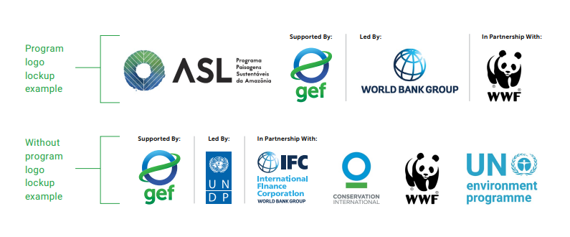

Websites, Newsletters:
GEF Program websites and projects can have their own visual identity as well. The GEF Program logo should be used on the front page, as well as the GEF logo and the lead agency logo. However, at the bottom of that first front page/homepage, the same lineup of logos needs to be added just as in publications. The same applies to the whole range of outreach material, such as email newsletters and other forms of an online presence.
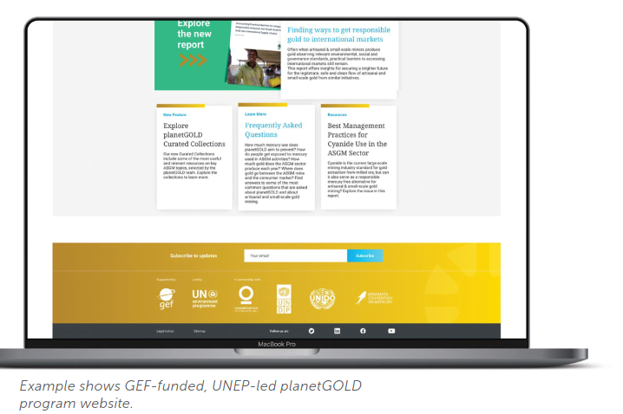
- Supported by: GEF logo
- Led by: Lead agency logo
- In partnership with: Partner organization logos

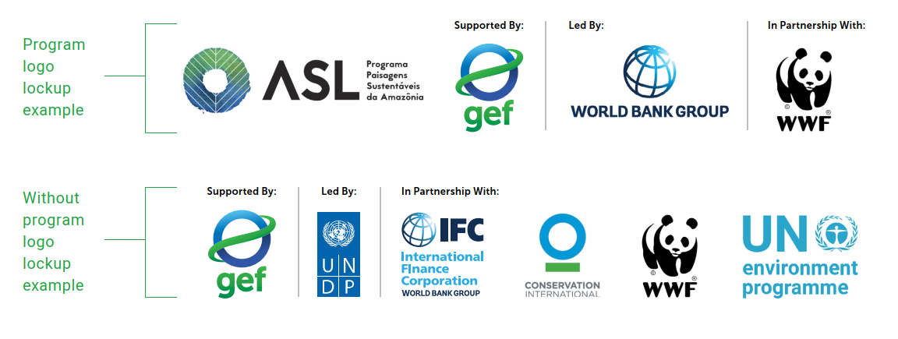
- Social Media:

GEF Program outreach materials need to be coordinated with the GEF Secretariat. The production of outreach material — not only publications — has to be done in coordination with the respective program managers and communications staff in the GEF Secretariat.

GEF Programs can create their own visual identity and create their own logo. This process needs to be in cooperation and agreement with the GEF Secretariat. The program logo should be used on the front cover together with the GEF logo and the lead agency logo as seen here in the example of the Amazon Sustainable Landscapes Program ASL brochure. On the back cover or the inside of the back cover, the following credit needs to be given to the GEF in the way the GEF logo is positioned vis-à-vis the partner logos:
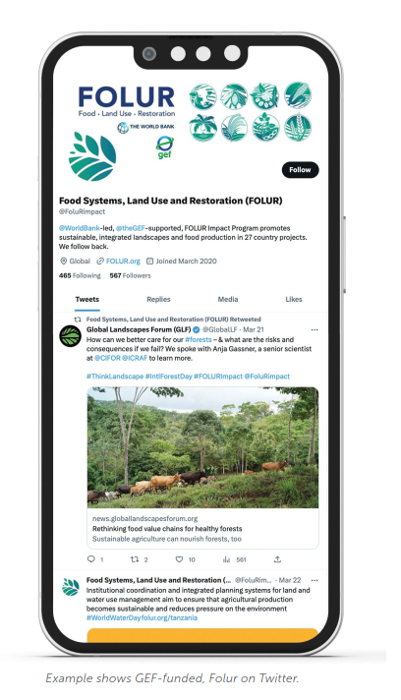
- Supported by: GEF logo
- Led by: Lead agency logo
- In partnership with: Partner organization logo

- WWF-US Brand Guidelines:
WWF brand gives the world their first visual impression of who WWF is and what it stands for. Because of that, it is critically important to have a strong, clear, compelling, and consistent branded look that carries across all printed materials.

Using the Panda symbol/logo:
WWF's panda symbol is a registered trademark and is subject to copyright. It must not be used or reproduced without express permission. The letters "WWF" are also registered trademarks and must not be used to endorse or promote any products or services in any way, shape, or form.
The official artwork in all its forms, and a copy of these guidelines, can be downloaded from the file that accompanies this document. Please make sure the logos you have match those shown below. If you have more questions, please refer to the WWF-US Brand Guidelines 2016, the WWF-US Brand Guidelines Editorial Style 2020 or send an email to the project manager of the project.

The legal fluff on the logo:
- © 1986 Panda Symbol WWF - World Wide Fund For Nature (formerly World Wildlife Fund).
- ® "WWF" & "Living Planet" are WWF Registered Trademarks.

WWF Panda logo use and placement:
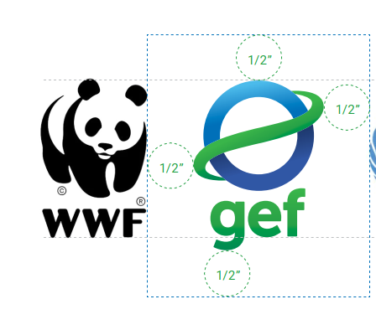

Institutional Statements:
- WWF Official Description: Use this copy when you need a clear, concise statement of who WWF is. Always end by directing the reader to the official website and use a more specific URL when appropriate (e.g., https://wwfgef.org/gef/).
  - About WWF: For almost 60 years, WWF has been protecting the future of nature. One of the world’s leading conservation organizations, WWF works in nearly 100 countries and is supported by more than 1 million members in the United States and more than 5 million globally. WWF’s unique way of working combines global reach with a foundation in science, involves action at every level from local to global, and ensures the delivery of innovative solutions that meet the needs of both people and nature. Visit worldwildlife.org to learn more.
- WWF’s Vision and Mission statements were approved as of November 18, 2011. The official description was updated on June 20, 2019.
- WWF’s vision is to build a future in which people live in harmony with nature.
- WWF’s mission is to conserve nature and reduce the most pressing threats to the diversity of life on Earth.

WWF Editorial Style:
- WWF Office Names: For consistency, the organization hyphenates the names of all WWF offices: WWF-International, WWF-US, WWF-UK, WWF-Ecuador, WWF-Nepal, WWF-Canada, WWF-Bhutan, etc.

- WWF Address Block: The standard address block is set this way and nearly always includes our web address one line down:

World Wildlife Fund
1250 24th Street,
NW Washington, DC 20037
worldwildlife.org
WWF’s main number (202-293-4800) is often included above the web address.

- WWF URL, worldwildlife.org, or wwf.org: For audiences within the US, wwf.org redirects to worldwildlife.org, so either one is acceptable. Using worldwildlife.org reduces potential delay from the redirect, but on communications that users will see only briefly—such as a PSA on a highway, billboard—wwf.org is easier to notice and recall. For audiences outside the US, where traffic should go to the WWF-US website, use worldwildlife.org. Outside the US, wwf.org takes users to a directory page showing WWF offices all over the world. Use wwf.org only if it's acceptable for users to end up at other country websites.

WWF Photo Credit & Caption Style:
- Photo Captions: If you choose to include a caption, include, at minimum, the following elements in this order: description, location, copyright. A local vet treats an injured rhino.
    - Sumatra, Indonesia © WWF-US/Barney Long
    - African elephant, Namibia © WWF-US/Betty McLaughlin Meyer.

- If WWF is the copyright owner: © WWF-US/Photographer’s name. If the photographer is hired by WWF but retains copyright ownership: © photographer's name/WWF-Nepal. WWF owns the rights if a WWF staff person took the photo while on WWF business: © WWF-UK/Staffer's name. If a WWF staff person took the photo during personal time: © Staffer's name.

WWF-US Sustainability Policy:
When making print purchases, follow WWF’s environmental standards policy for paper and printing. Supply your printer with a copy of this policy so they can provide you with an accurate price quote.
- Paper: Use Forest Stewardship Council (FSC)-certified papers that are 100% recycled, with a preferred minimum of 30% post-consumer waste (PCW). If this percentage is not possible, you may use no less than an absolute minimum of 10% PCW. The use of virgin pulp is acceptable as long as the paper is certified by FSC.

- Printing: Make sure your vendor is FSC-certified and committed to sustainable print practices. The FSC-certified paper should be used whenever possible. The FSC logo should appear on all printed materials, including envelopes. The printer should supply you with a "for position only" (FPO) copy of the appropriate logo, and you should incorporate it into your layout design. Remember to remove the FSC logo when posting a document online or sending it as a PDF.

https://www.thegef.org/sites/default/files/documents/C.40.08_Visibility-2011_0.pdf
https://www.thegef.org/sites/default/files/publications/GEF30_Brand%20Guidelines_June2021_r1.pdf
Communication and Visibility | Global Environment Facility (thegef.org)
https://www.thegef.org/sites/default/files/publications/GEF30_Brand%20Guidelines_June2021_r1.pdf
https://www.thegef.org/sites/default/files/documents/C.40.08_Visibility-2011_0.pdf
https://www.thegef.org/gef-logo
https://www.thegef.org/sites/default/files/publications/GEF30_Brand%20Guidelines_June2021_r1.pdf
https://www.thegef.org/sites/default/files/documents/C.40.08_Visibility-2011_0.pdf
Please download this document from the brand package file.
Please download this document from the brand package file.
http://awsassets.panda.org/downloads/wwf_responsible_paper_policy_2018_word.pdf

