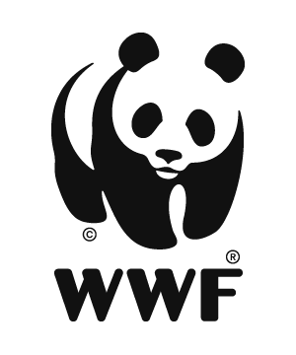
WWF GEF Agency
Six Month Project Progress Report

Title (GEF ID)

1. General  Information | Agency Approval Date
 | Fiscal Year
2. Budget | Total Project Budget
 | Total GEF Budget Spent (USD) for given project year
 | Materialized Co-finance

Project Report information:
Report Author(s)
Report Completion Date
Reporting Period

Project Contact information:
Project Position | Name | E-mail
Project Manager
M&E Officer
F&A Officer

Instructions:
The time period for this report is the first six months of the current project year. Please submit the 6-month PPR to the WWF GEF Project Manager. Please annex any supporting documents: workplan tracking (if applicable), meeting minutes, stakeholder consultation, photos, maps, reports, etc. You may erase gray text when submitting report.

Outcomes and Impacts Achieved
Describe the key outcomes and impacts achieved during the six-month reporting period, using the AWP&B and Results Framework as a reference. Please note any major positive or negative effects on beneficiaries. Organize by component and project objective.

Summary of Major Challenges and Strengths
Describe the major challenges and strengths that hindered or enabled performance for the six-month reporting period.

Progress, Challenges, and Outcomes of Stakeholder Engagement

(Based on Stakeholder Engagement Plan included at CEO Endorsement)
Describe progress, challenges, and/or outcomes of stakeholder engagement, including strategies taken to ensure gender and social inclusion.

Summarize for previous reporting periods (~2 paragraphs):

For six-month reporting period:

Information on Progress on Gender-Responsive Measures

(As documented at CEO Endorsement in the Gender Action Plan or Equivalent)
Provide the completion dates for: the gender assessment or analysis and gender mainstreaming strategy/action plan (GEF-7). __ /__ / ____

Describe gender responsive activities.

Summarize for previous reporting periods (~2 paragraphs):

For six-month reporting period:

Implementation of Workplan and Budget
Explain whether the workplan is being implemented to schedule and justify any changes. Describe any major over or underspends or shifts in budget. Note if the project is able to document and comply with Environmental and Social Safeguards when implementing the work plan.

Lessons Learned
Describe key lessons from this six-month report period that the project team learned and believe are important to share. Reflect on what has worked and not worked in relation to the project theory of change.

Adaptive Management
Describe changes made or needed to project components, outcomes and/or strategies, or whether any changes are planned for this or coming years.

