Project Governance Examples

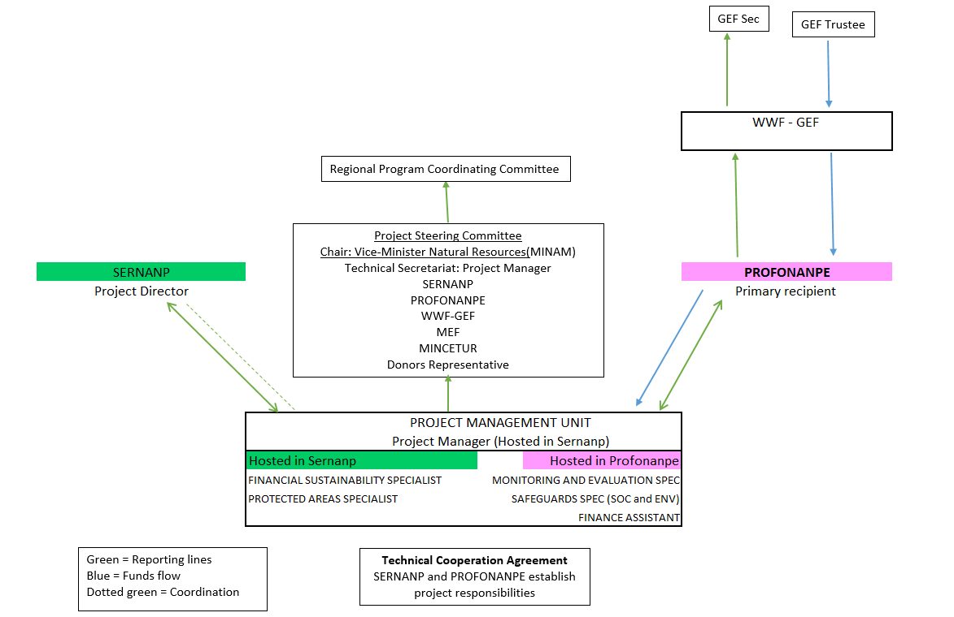
Securing the Future of Peru’s Natural Protected Areas
Generating Responsible Demand for Reduced Deforestation Commodities

